Task Management System User Manual
Introduction
The Task Management System is a desktop application designed to help users organize, prioritize, and track their tasks efficiently. The system provides an easy-to-use graphical interface where users can add tasks, assign priorities, set due dates, and manage task completion. Tasks are separated into pending and completed categories, allowing users to clearly monitor their progress.
System Requirements
- Java installed (JDK 8 or higher)
- Any system capable of running Java applications
- IDE (optional, for running the project)
How to Launch the Application
- Open your Java IDE (such as Eclipse or IntelliJ), or locate the compiled .class file.
- Run the TaskManagerGUI class.
- The application window will open displaying the task management interface.
Overview of the Interface
The application is divided into three main sections:
1. Top Panel
- Sort by Priority – Sorts pending tasks based on priority (High → Low)
- Sort by Due Date – Sorts tasks by earliest due date
- Exit – Closes the application and saves tasks
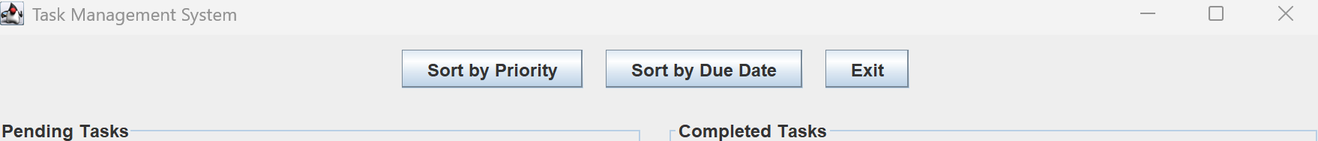

2. Center Panel
Pending Tasks (Left Side)
- Displays all active tasks
- Tasks are color-coded:
  - Red – High priority
  - Orange – Medium priority
  - Green – Low priority
Buttons:
- Mark as Complete – Moves selected task to completed list
- Remove Task – Deletes selected task
Completed Tasks (Right Side)
- Displays finished tasks
- Styled in blue and italic font for easy identification
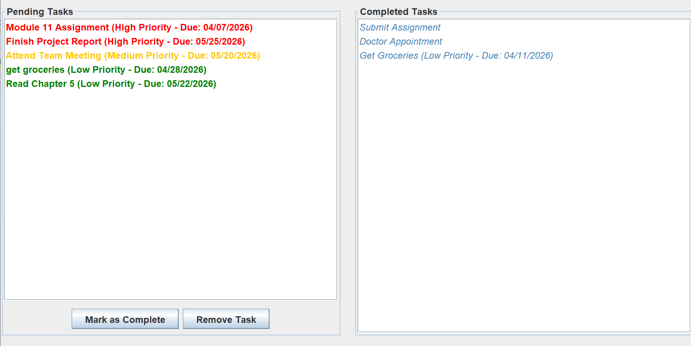
3. Bottom Panel (Add New Task)
Fields:
- Task Description – Enter the task name
- Priority – Select High, Medium, or Low
- Due Date – Enter date in MM/DD/YYYY format
Buttons:
- Add Task – Adds the task to the pending list
- Cancel – Clears all input fields
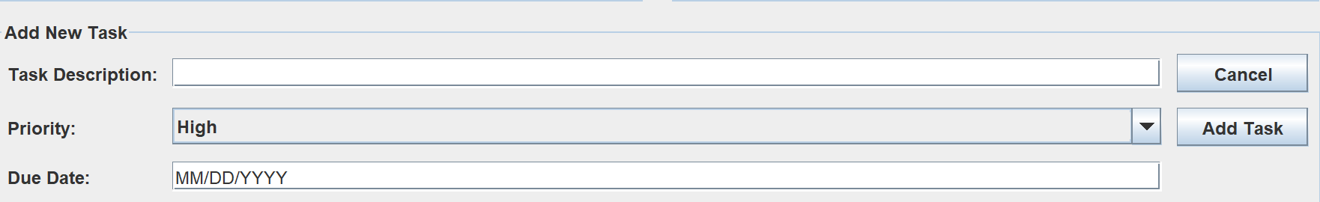
How to Use the Application
Adding a Task
- Enter a description in the Task Description field
- Select a priority level
- Enter a due date in MM/DD/YYYY format
- Click Add Task
⚠️ Notes:
- Description cannot be empty
- Due date must be valid and not in the past
Completing a Task
- Select a task from the Pending Tasks list
- Click Mark as Complete
- The task will move to the Completed Tasks list
Removing a Task
- Select a task from the Pending Tasks list
- Click Remove Task
Sorting Tasks
- Click Sort by Priority to organize tasks by importance
- Click Sort by Due Date to organize tasks by deadline
Clearing Input Fields
- Click Cancel to reset all input fields
Exiting the Application
- Click Exit or close the window
- All tasks will be automatically saved
Data Storage
- Tasks are saved in a file named tasks.txt
- The file stores both pending and completed tasks
- Tasks are automatically loaded when the application starts
Error Handling
The system provides messages for:
- Missing task description
- Invalid date format
- Past due dates
- No task selected when performing actions
Tips for Best Use
- Always enter dates in MM/DD/YYYY format
- Regularly sort tasks to stay organized
- Use priority colors to quickly identify urgent tasks
Known Limitations
- Tasks cannot currently be edited after creation
- No search or filter functionality
- Data is stored locally (not cloud-based)
Future Improvements
- Edit existing tasks
- Add notifications/reminders
- Implement search and filtering
- Upgrade to database storage
- Expand to mobile or web platform

